Design document



CELLPHONE ELIMINATOR

ECE 198-Section 3-Group 56

BRYAN KUANG, LINGFENG XIAO

Table of Contents

Needs Assessment 2

Client/Customer Definition 2

Competitive Landscape 3

Requirement Specification 3

Analysis 5

Design 5

Scientific or Mathematical Principles 6

Cost 9

Manufacturing Costs 9

Implementation Costs 10

Risk 12

Energy Analysis 12

Risk Analysis 12

Testing and Validation 14

Test Plan 14

# Needs Assessment

## Client/Customer Definition

Demographic: The product is designed for teens since there is a survey showing this group of people have severe problems with phone usage. Approximately 54% of teens admit to spending too much time on their phones [1]. Spending too much time on our phones will result in serious medical conditions, and nerve damage is one of the results [2], which will seriously reduce working efficiency.

Geographic: The product aims to help Engineering undergraduate students at the University of Waterloo (Around 9,000 people [3]) control their time on phones.

Economic: The product will use materials and components that are cheap and easy to get to ensure university students are financially capable of buying it after paying their tuition.

##### References:

1. M. Montgomery. “Mobile phones: too much time for children and parents.” Radio Canada International. https:/[/www](http://www.rcinet.ca/en/2018/08/27/mobile-phones-too-much-).[rcinet.ca/en/2018/08/27/mobile-phones-too-much-](http://www.rcinet.ca/en/2018/08/27/mobile-phones-too-much-) time-for-children-and- parents/#:~:text=Some%2054%20per%20cent%20of%20teens%20asked%20said,con cerned%20over%20their%20children%E2%80%99s%20use%20of%20the%20phones (accessed Sept. 18, 2023).
2. “15 Damaging Health Effects of Using Smartphones Everyday”. MobileCon. https:/[/www](http://www.mobilecon2012.com/15-damaging-health-effects-of-using-smartphones-).[mobilecon2012.com/15-damaging-health-effects-of-using-smartphones-](http://www.mobilecon2012.com/15-damaging-health-effects-of-using-smartphones-) everyday/. (accessed Sept. 29, 2023).
3. “Faculty of Engineering Statistics 2021”. University of Waterloo. https://uwaterloo.ca/engineering/about/faculty-engineering-statistics (accessed Sept. 18, 2023).

## Competitive Landscape

1. **Parental Control Apps:** Apps that allow parents to monitor and control their children’s phone usage by setting screen time limits and block certain apps.

Shortcomings: Children might find ways to disable or bypass these controls, and it is not helpful to train children to control their phone usage by themselves [1].

1. **Digital Wellbeing Features:** Integrated features that allow users to set daily limits on app usage. Encouraging users to be mindful of their phone usage.

Shortcomings: The features largely rely on users' self-discipline to enforce limits; users can regret the limits set by themselves at any time. Also, the features could randomly switch themselves off due to bugs [2].

1. **Digital Detox Retreats and Programs:** A social program that offers the participants a chance to be in an environment free from their screens. It encourages participants to engage in physical fitness and social activities instead of online activities.

Shortcomings: Such retreats are normally very expensive [3].

##### Reference:

1. “Pros And Cons Of Parental Controls On Apps.” The ONION. <https://www.theonion.com/pros-and-cons-of-parental-controls-on-apps-1849490846> (accessed Oct. 20, 2023).
2. “Screen Time is broken for many parents; Apple admits previous fix didn’t resolve.” 9TO5Mac. https://9to5mac.com/2023/07/31/screen-time-is- broken/#:~:text=Many%20parents%20are%20reporting%20that%20Screen%20Time

%20limits,those%20using%20the%20public%20beta%20of%20iOS%2017. (accessed Oct. 20, 2023).

1. “Digital Detox Retreats.” BookRetreats. [https://bookretreats.com/s/wellness-](https://bookretreats.com/s/wellness-retreats/digital-detox-retreats) [retreats/digital-detox-retreats](https://bookretreats.com/s/wellness-retreats/digital-detox-retreats) (accessed Oct. 20, 2023).

## Requirement Specification

**Emergency Unlock:** The product shall allow users to open the box by pressing the emergency button. Users shall be allowed to use the emergency button 2 times per

day, which is a reasonable number compared to the average of 0.00108 unscheduled emergencies per person per day in Canada [1].

**Time Duration Control:** Users shall be able to set a specific duration for phone usage control, usually 0.5 to 2 hours as this is the average attention span of human [2].

**User-Friendly Interface:** The product shall feature an intuitive user interface, including a clear display or status indicators. The luminance for display shall be around 250 to 300 candelas per square meter according to [3].

**Compatibility:** The product shall be able to hold phones with various sizes of screens. According to the market, the usual size of a phone ranges from 4 inches to 7 inches [4].

**Emergency Access Respond Time:** The product shall open itself in 0.3 seconds after the emergency button is pushed as [5] states.

##### References:

1. “NACRS emergency department visits and lengths of stay.” Canadian Institute for Health Information. https:/[/www](http://www.cihi.ca/en/nacrs-emergency-department-visits-and-).[cihi.ca/en/nacrs-emergency-department-visits-and-](http://www.cihi.ca/en/nacrs-emergency-department-visits-and-) lengths-of- stay#:~:text=NACRS%20data%20shows%20that%20from%20April%202022%20to,

%E2%80%94%20up%20from%20almost%2014.0%20million%20in%202021%E2% 80%932022. (accessed Sept. 19, 2023).

1. “What is your optimal focus time for your maximum productivity.” Next Evolution Performance. https://nextevolutionperformance.com/2017/02/optimal- focus-time-maximum-productivity/ (accessed Sept. 19, 2023).
2. *ISO 9241-307:2017 (Ergonomics of Human-System Interaction - Part 307: Analysis and compliance test methods for electronic visual displays)*, Geneva, Switzerland, 2008.
3. “What size smartphone do you need?” Cool Blue. https:/[/www](http://www.coolblue.be/en/advice/smartphone-screens.html).[coolblue.be/en/advice/smartphone-screens.html](http://www.coolblue.be/en/advice/smartphone-screens.html) (accessed Sept. 19, 2023).
4. *ISO 13850:2015 - Safety of machinery - Emergency stop - Principles for design*. International Organization for Standardization, Geneva, Switzerland, 2015.

# Analysis

## Design

The main body of the product is a cardboard box that will be used to contain the phone. The motor, display, and joystick that used to control the time duration will be placed on the box as the first diagram shows. The STM32 (Nucleoboard) and wires will be place in a mezzanine as the second diagram shows.

The joystick is used to control the cursor displays on the display, allowing the user to select time of containment of their phone.

To see the detailed Wiring diagram, please check the Installation Manual on the Implementation Cost section.

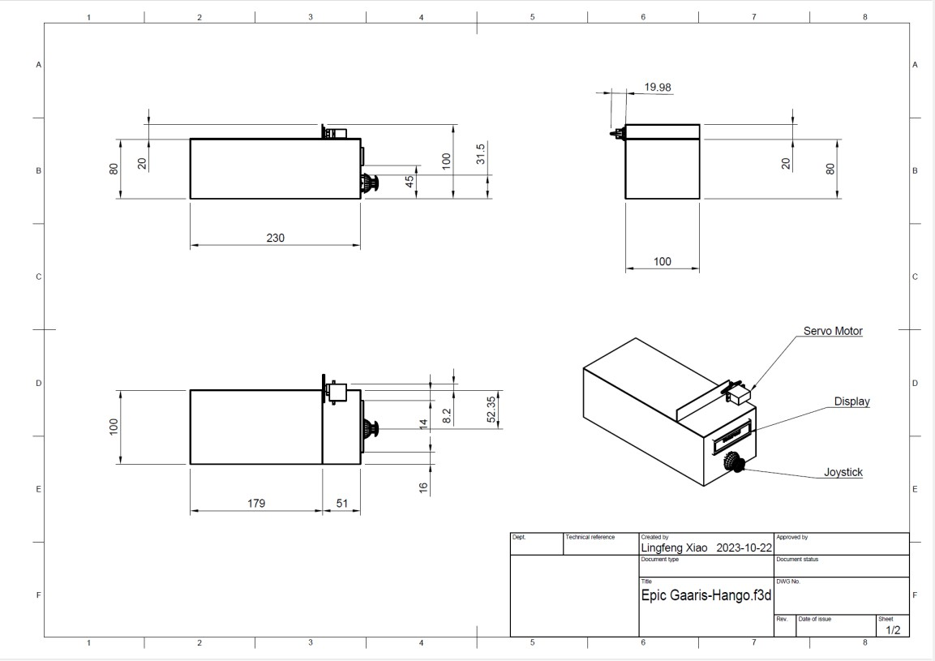

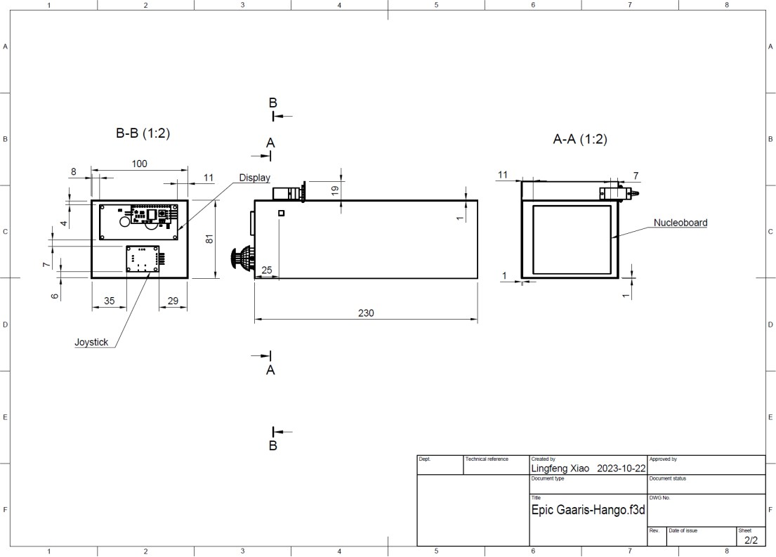

Revisional Version:

## Scientific or Mathematical Principles

1. The scientific principle of torque, W=mg, will be used to calculate the minimum force required to open the box. The result equals the product of gravitational constant and the mass of the box lid [1].
   * A typical 9″ x 6″ x 2″ cardboard box can hold the majority sizes of phones, the mass of the box lid is approximately 5g, thus its gravitational force is 0.005kg*9.8N/kg=0.049N.

The principle and its result will be brought into principle 2 to calculate the torque it requires to open the box. Eventually it will be applied to calculate the time it takes to open the box lid (**Emergency Access Respond Time**).

1. The scientific principle of torque, T=r*F, will be applied to open the box lid after the countdown. The formula helps calculate the minimum torque should be applied to open the box lid, as it equals the product of distance between the edge of box lid and motor, and the minimum force required to open the box, in this case, the gravitational force W of the box lid [2].
   * The distance between the motor and the edge of the box lid is around 0.10m. Accordingly, the total torque required to open the box would be

0.10m*0.049N=0.0049N*m.

The principle and its result will be brought into principle 4 to calculate the angular acceleration of the box lid once it is opened. Eventually it will be applied to calculate the time it takes to open the box lid (**Emergency Access Respond Time**).

1. The scientific principle of inertia, 𝐼 = 𝑏ℎ3, will be used to calculate the inertia of

12

the box lid. The result equals the product of width and height³ (in this case, the length³) of the box lid about the rotational axis, divided by 12 [3].

* + The length and width of the box lid is b=0.10m h=0.23m, thus the inertia of the box lid is (0.10m*(0.23m³)/12 = 0.000101 kg m².

The principle and its result will be brought into principle 4 to calculate the angular acceleration of the box lid once it is opened. Eventually it will be applied to calculate the time it takes to open the box lid (**Emergency Access Respond Time**).

1. The scientific principle of torque, Α = τ/I, will be used to calculate the angular acceleration of box lid once it is opened and the torque remains changed. Both elements required to calculate the result are given from the previous calculations [4].
   * τ=0.0049N*m, I=0.000101 kg m². Thus, the angular acceleration of the box lid once it is opened will be 0.0049N*m/0.000101 kg m²=48.3radians/s².

The principle and its result will be brought into principle 5 to calculate the time it takes to open the box lid (**Emergency Access Respond Time**).

1. The scientific principle of torque, 𝑡 = √2𝜃, which is a variation from the formula

𝛼

θ final= θ initial + ω initial t + ½αt², will be used to calculate the time it takes to open the box lid if the torque remains unchanged (which in our case is a fact).

* + 𝜃 = 𝜋 2

radians, 𝛼=48.3 radians/s². Thus, t=√ 𝜋 radians

48.3 radians/s²

=0.0650s

According to the Requirement (**Emergency Access Respond Time**), the box should open itself in 0.3 seconds after the emergency button is pushed. According to the calculations, the box needs a maximum of 0.065 seconds for it to open itself, leaves a minimum time of 0.235 seconds for the system to respond.

1. The scientific principle of Kirchhoff's voltage law, v1+v2+v3+v4+…=0, will be applied to calculate the amount of power we will allocate to each component [6].
   * STM32 can output 3.3v, the product will use a parallel circuit that each loop be allocated one component (display, control, motor). Thus, each component will be allocated 3.3v.

This principle will used to ensure each component will have enough voltage it required for its running.

##### References:

1. “Weight.” Wikipedia. https://en.wikipedia.org/wiki/Weight (accessed Sept. 18, 2023).
2. “Torque.” Wikipedia. https://en.wikipedia.org/wiki/Torque (accessed Sept. 18, 2023).
3. “Moments of Inertia.” LibreTexts ENGINEERING. https://eng.libretexts.org/Bookshelves/Mechanical_Engineering/Engineering_Statics

%3A_Open_and_Interactive_(Baker_and_Haynes)/10%3A_Moments_of_Inertia/10.0 2%3A_Moments_of_Inertia_of_Common_Shapes (accessed Sept. 18, 2023).

1. “Torque Formula (Moment of Inertia and Angular Acceleration).” SoftSchools. https:/[/www](http://www.softschools.com/formulas/physics/torque_formula/59/).[softschools.com/formulas/physics/torque_formula/59/](http://www.softschools.com/formulas/physics/torque_formula/59/) (accessed Sept. 18, 2023).
2. “Frequently Used Equations.” The Physics Hypertextbook. https://physics.info/equations/ (accessed Sept. 18, 2023).
3. “Kirchhoff's circuit laws.” Wikipedia. https://en.wikipedia.org/wiki/Kirchhoff%27s_circuit_laws. (accessed Sept. 18, 2023).

# Cost

## Manufacturing Costs

Materials:

* + Carboard
  + Tape/glue Technologies:
  + STM32CubeIDE
  + Code compiler Component:
  + Servo motor:

Manufacturer: Freenove (Shenzhen, Guangdong 518110, CN) Vendors/Distributors: Amazon (410 Terry Avenue North, Seattle, Washington)

* + Display:

Manufacturer: Freenove (Shenzhen, Guangdong 518110, CN) Vendors/Distributors: Amazon (410 Terry Avenue North, Seattle, Washington)

* + Joystick:

Manufacturer: Freenove (Shenzhen, Guangdong 518110, CN) Vendors/Distributors: Amazon (410 Terry Avenue North, Seattle, Washington)

* + Wires:

Manufacturer: Freenove (Shenzhen, Guangdong 518110, CN) Vendors/Distributors: Amazon (410 Terry Avenue North, Seattle, Washington)

* + STM32:

Manufacturer: STMicroelectronics (350 Burnhamthorpe Rd W Suite 604, Mississauga Ontario L5B 3J1)

Vendors/Distributors: Wstore (200 University Ave W, Waterloo On N2l 3g1)

* + USB cable:

Manufacturer: STMicroelectronics (350 Burnhamthorpe Rd W Suite 604, Mississauga Ontario L5B 3J1)

Vendors/Distributors: Wstore (200 University Ave W, Waterloo On N2l 3g1)

## Implementation Costs

### Installation Manual:

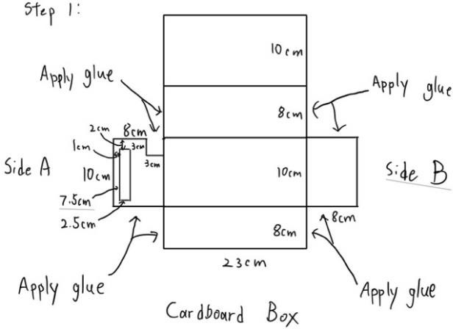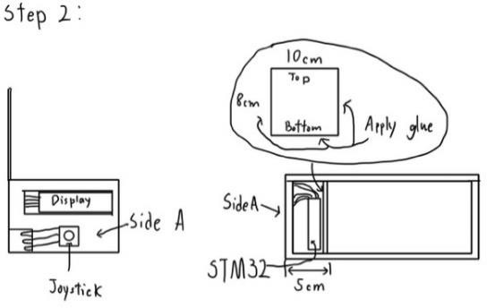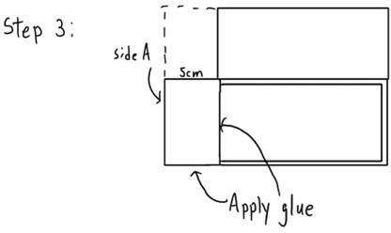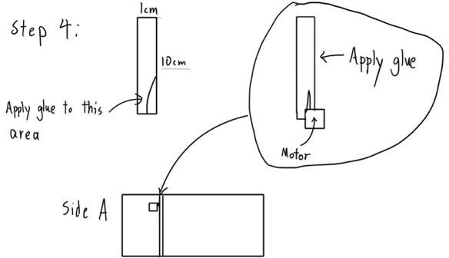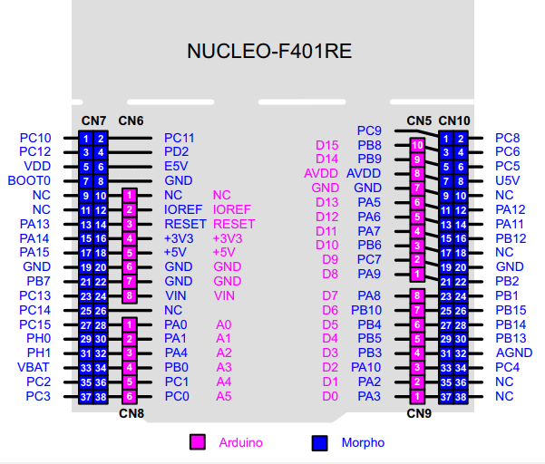

i2c 16x2 lcd display: GND->GND; VCC->5V; SDA -> D14; SCL->D15 Joystick: GND->GND; 5V->3.3V; VRX->PA6; VRY -> PA7 SW->PB0

Servo Motor: Brown wire -> GND; Red wire->5V; Yellow wire->PC6

### User Guide:

#### Cell Phone Locker Timer

This user guide explains how to use the Cell Phone Locker Timer, a device designed to lock your cell phone for a specified duration. You can lock your phone and choose when it unlocks. Here's how to use it:

##### Locking Duration Selection:

* + Begin by positioning your cursor one block before the first character of the time selection.
  + You can set the lock duration in hours ("hr"), minutes ("min"), and seconds ("sec").
  + Increment the current time unit by 1, 5, 10, or 20 as needed.
  + Hours can be set from 0 to 23, while minutes and seconds range from 0 to 59.
  + Your lock duration must fall within the range of 0 to 3,599 seconds.
  + Use the "->" button to move to the next unit, or "<-" to go back to the previous unit.
  + When you reach seconds as the current unit, clicking "->" will take you to the confirmation screen.

##### Confirmation Screen:

* + In this phase, you will see the total lock duration you've selected displayed on the screen.
  + You can choose to either "Start" the locking process or "back" to return to the time selection phase.

##### Locking Phase:

* + During the countdown phase, the cell phone locker is closed, preventing access to your phone.
  + The remaining lock time is visible on the interface.
  + If you need to pause the locking process, press "pause." The number of pauses remaining is displayed.
  + The locker can be opened during a pause, and it won't restart until you press "Restart."
  + After the lock time is complete, you can press a button to re-enter the process of selecting a new lock duration.

This user guide provides instructions on how to effectively use the Cell Phone Locker Timer to control your phone's access. Enjoy the benefits of a controlled phone usage experience.

# Risk

## Energy Analysis

According to the ECE 198 Project Requirements, the design must not consume, transfer, discharge, or otherwise expend more than 30W of power at any point in time and within any component of the design during its operation.

The power will be supplied through a cable with USB 2.0 port, which normally can provide up to 2.5W (5V and 0.5A).

STM32 is directly connected with the USB cable. All other 3 components are connected to STM32 in a parallel circuit that each loop has only one component. All 3 components are connected to 3.3V output slot of the STM32, meaning each of them are allocated with 3.3V. All these components can operate in the range of 3.3V to 5V, meaning it will consume all voltage allocated to it. Thus, no significant energy storage could occur.

The system only has electrical energy, thus the maximum total energy stored within the system under operation would be 2.5W.

The maximum volt of the system would be 2.5W, which is lower than the 30W limit. Thus, the limit is not exceeded.

## Risk Analysis

##### Possible Negative Consequences on Safety or the Environment from Using the Design as Intended:

* + If the user put something that is much larger than the compacity of the product, it will lead to the malfunction of the product or break the product completely.
  + It will cause wastes (including e-waste) that will negatively impact the environment and hurt users physically.

##### Possible Negative Consequences on Safety or the Environment from Using the Design Incorrectly:

* + If the user mishandles the joystick or manipulate it in a way not intended by the product's design, it will lead to the malfunction of the joystick which will cause the user unable to input the correct value they want. In the worst case, it

will break the product, causing short-circuit that will hurt user physically and produce wastes that will negatively impact the environment.

* + If the user tries to open the box by force it will break the motor of the box. Leading to safety concerns and potential environmental consequences when attempting to repair or replace damaged parts.

##### Possible Negative Consequences on Safety or the Environment from Misusing the Design:

* + Misuse of the product to forcibly open the box could potentially lead to unauthorized access to the user's phone, compromising their privacy and data security.

##### Possible Ways the Design Could Malfunction:

* + Using the product for a long period of time without maintenance could lead to the failure of motor, joystick, or the display.
  + A strong impulse or electromagnetic interference could cause the electrical components to be malfunction.

##### Consequences on Safety or the Environment for Each Failure Mechanism:

* + Joystick Failure: Users will not be able to enter the correct value they want. Environmental consequences would likely be limited unless the joystick components are not disposed of properly.
  + Motor Failure: The box will not be able to open itself. This could lead to safety concerns when the user wants to retrieve their phone. Environmental consequences could arise if the motor components are not disposed of properly.
  + Display Failure: The user will not be able to read their action while operating the system. They will also not be able to read how much time is left for the containment duration. Environmental consequences could arise if the display components are not disposed of properly.

# Testing and Validation

## Test Plan

##### Emergency Unlock

Objective:

* + Verify whether the product allows users to open the box by pressing the emergency button and enforces the restriction of allowing users to use the emergency button only 2 times per day.

Test Setup:

* + The product prototype with the emergency button and the motor that open the box.
  + Necessary power sources and connections.

Environmental Parameters:

* + Temperature: Room temperature (20-22 °C).
  + Humidity: Room humidity (30% and 60%).
  + No electromagnetic interference or external disruptions.

Test Inputs:

* + Emergency button push.

Test Procedure:

* + Ensure that the product is in a standby state.
  + Push the emergency button.
  + After the first button press, try to press the button again. Record the system's response.
  + Repeat steps 2-4 to reach the limit of 2 emergency button presses per day.
  + Attempt additional button presses beyond the limit to verify that the system restricts further usage.

Quantifiable Measurement Standard:

* + The quantifiable measurement standard is the number of times the emergency button is allowed to be pressed per day (2 times).

Pass Criteria:

* + The product passes the test if it allows users to open the box using the emergency button a maximum of 2 times per day and restricts further usage. If it fails to meet this requirement, it is considered a failure.

##### Time Duration Control

Objective:

* + Verify whether users can set a specific duration for phone usage control within the range of 0.5 to 2 hours.

Test Setup:

* + The product prototype with user interface controls (Display and joystick).
  + Necessary power sources and connections.

Environmental Parameters:

* + Temperature: Room temperature (20-22 °C).
  + Humidity: Room humidity (30% and 60%).
  + No electromagnetic interference or external disruptions.

Test Inputs:

* + Use the joystick to input the time value.

Test Procedure:

* + Ensure that the product is in a standby state.
  + Set the phone usage control duration within the specified range (0.5 to 2 hours).
  + Activate the timer.
  + Verify that the phone usage control deactivates after the set duration.

Quantifiable Measurement Standard:

* + The quantifiable measurement standard is the duration set by the user, which should fall within the range of 0.5 to 2 hours.

Pass Criteria:

* + The product passes the test if users can set a duration for phone usage control within the specified range, and the control deactivates the phone after the set duration. If it fails to meet this requirement, it is considered a failure.

##### User-Friendly Interface

Objective:

* + Verify whether the luminance for display is within the specified range of 250 to 300 candelas per square meter.

Test Setup:

* + The product prototype with the Display of it.
  + Necessary power sources and connections.

Environmental Parameters:

* + Temperature: Room temperature (20-22 °C).
  + Humidity: Room humidity (30% and 60%).
  + No electromagnetic interference or external disruptions Test Inputs:
  + Display lighted.

Test Procedure:

* + Ensure that the product is in a standby state.
  + Turn on the Display and wait until it is completely lighted up.
  + Use a device such as a photometer to measure the brightness of the display in candelas per square meter.
  + Record the result.
  + Repeat the test 3 times to ensure the accuracy of the data.

Quantifiable Measurement Standard:

* + The quantifiable measurement standard is the luminance of the display of the product (250 to 300 candelas per square meter).

Pass Criteria:

* + The product passes the test if the average of all test results is within the specified range. If the average result is not within the range, it is considered a failure.

##### Compatibility

Objective:

* + Verify whether the product can hold phones within the usual size range

of 4 inches to 7 inches.

Test Setup:

* + The product prototype.
  + Phones with screen sizes ranging from 4 inches to 7 inches.

Environmental Parameters:

* + Temperature: Room temperature (20-22 °C).
  + Humidity: Room humidity (30% and 60%).
  + No electromagnetic interference or external disruptions.

Test Inputs:

* + Placing phones of different sizes into the product.

Test Procedure:

* + Place a phone with a 4-inch screen into the product.
  + Verify that the product securely holds the phone without issues.
  + Repeat the test with phones of increasing screen sizes (e.g., 5 inches, 6 inches, 7 inches).
  + Verify that the product accommodates all tested phone sizes securely.

Quantifiable Measurement Standard:

* + The quantifiable measurement standard is the range of phone sizes (4 inches to 7 inches) that the product can securely hold.

Pass Criteria:

* + The product passes the test if it can securely hold phones with screen sizes within the specified range. If it fails to meet this requirement for any tested size, it is considered a failure.

##### Emergency Access Respond Time

Objective:

* + Verify whether the product can open itself in 0.3 seconds after the emergency button is pushed.

Test Setup:

* + The product prototype with the emergency button and the motor that open the box.
  + A stopwatch or timer for accurate time measurement.
  + Necessary power sources and connections.

Environmental Parameters:

* + Temperature: Room temperature (20-22 °C).
  + Humidity: Room humidity (30% and 60%).
  + No electromagnetic interference or external disruptions.

Test Inputs:

* + Emergency button push.

Test Procedure:

* + Ensure that the product is in a standby state, ready for the emergency button to be pushed.
  + Position the stopwatch or timer for accurate time measurement.
  + Push the emergency button.
  + Measure and record the time it takes for the product to open itself fully.
  + Repeat the test 3 times to ensure consistency.

Quantifiable Measurement Standard:

* + The quantifiable measurement standard is the time taken for the product to open itself after the emergency button is pushed (0.3 seconds).

Pass Criteria:

* + The product successfully opens itself within 0.3 seconds in all three tests. If the product fails to meet this requirement in any of the test runs, it will be considered a failure.